COMSATS University Islamabad



Department Of Computer Science

Course | Programming Fundamentals LAB
Course Code | CSC103
Instructor | Ms. Ayesha Bibi
Assignment No. | 7
Student Details

Name | Muhammad Haider Akbar
Registration No | SP26-BCS-062

Task 1
Write a method that computes the sum of the digits in an integer. Use the following method
header: public static int sumDigits(long n). For example, sumDigits(234) returns 9 (2 + 3 + 4).
import java.util.Scanner;

public class Task1 {

public static int sumDigits(long n) {
n = Math.abs(n);
int sum = 0;
while (n > 0) {
sum += n % 10;
n /= 10;
}
return sum;
}

public static void main(String[] args) {
Scanner input = new Scanner(System.in);
System.out.print("Enter an integer: ");
long n = input.nextLong();
System.out.println("Sum of digits: " + sumDigits(n));
}

Output

Task 2
Write the methods with the following headers
// Return the reversal of an integer, i.e., reverse(456) returns 654
public static int reverse(int number)
// Return true if number is a palindrome
public static boolean isPalindrome(int number)
Use the reverse method to implement isPalindrome. A number is a palindrome if its reversal is the same
as itself. Write a test program that prompts the user to enter an integer and reports whether the integer is
a palindrome.
import java.util.Scanner;

public class Task2 {

public static int reverse(int number) {
int reversed = 0;
int temp = Math.abs(number);

while (temp > 0) {
reversed = reversed * 10 + (temp % 10);
temp /= 10;
}

return number < 0 ? -reversed : reversed;
}

public static boolean isPalindrome(int number) {
return number == reverse(number);
}

public static void main(String[] args) {
Scanner input = new Scanner(System.in);
System.out.print("Enter an integer: ");
int number = input.nextInt();

int originalLength = String.valueOf(Math.abs(number)).length();
String reversedStr = String.format("%0" + originalLength + "d", reverse(number));
System.out.println("Reversed: " + reversedStr);

if (isPalindrome(number))
System.out.println(number + " is a palindrome.");
else
System.out.println(number + " is not a palindrome.");
}
}

Output
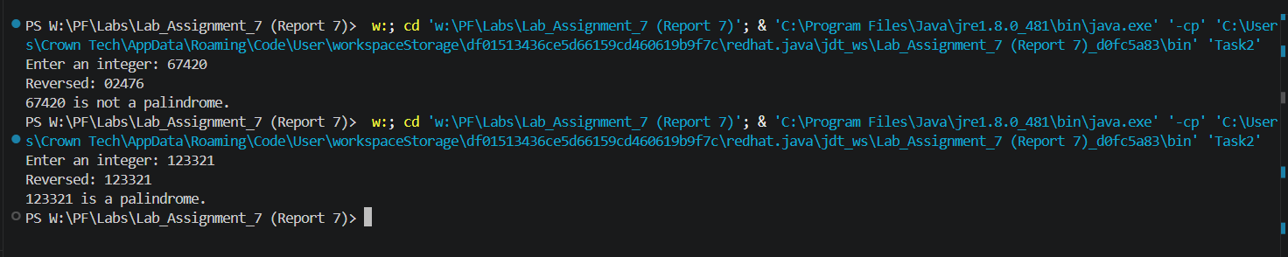

Task 3

Write a method with the following header to display three numbers in increasing order:

public static void displaySortedNumbers(double num1, double num2,

double num3)

Write a test program that prompts the user to enter three numbers and invokes the method to display them

in increasing order.
import java.util.Scanner;

public class Task3 {

public static void displaySortedNumbers(double num1, double num2, double num3) {
double temp;
if (num1 > num2) { temp = num1; num1 = num2; num2 = temp; }
if (num1 > num3) { temp = num1; num1 = num3; num3 = temp; }
if (num2 > num3) { temp = num2; num2 = num3; num3 = temp; }

System.out.println("Sorted: " + num1 + " " + num2 + " " + num3);
}

public static void main(String[] args) {
Scanner input = new Scanner(System.in);
System.out.print("Enter three numbers: ");
double num1 = input.nextDouble();
double num2 = input.nextDouble();
double num3 = input.nextDouble();

displaySortedNumbers(num1, num2, num3);
}
}

Output

Task 4
Write a method that returns the number of days in a year using the following header:
public static int numberOfDaysInAYear(int year)
Write a test program that displays the number of days in year from 2000 to 2020.
public class Task4 {

public static int numberOfDaysInAYear(int year) {
if ((year % 4 == 0 && year % 100 != 0) || (year % 400 == 0))
return 366;
else
return 365;
}
public static void main(String[] args) {
for (int year = 2000; year <= 2020; year++)
System.out.println(year + ": " + numberOfDaysInAYear(year) + " days");
}
}

Output

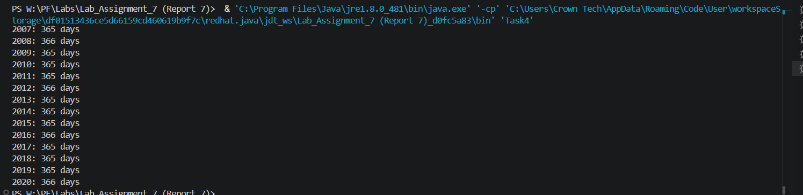

Task 5
Write a method that counts the number of letters in a string using the following header:
public static int countLetters(String s)
Write a test program that prompts the user to enter a string and displays the number of letters in the
string.
import java.util.Scanner;

public class Task5 {

public static int countLetters(String s) {
int count = 0;
for (int i = 0; i < s.length(); i++)
if (Character.isLetter(s.charAt(i)))
count++;
return count;
}

public static void main(String[] args) {
Scanner input = new Scanner(System.in);
System.out.print("Enter a string: ");
String s = input.nextLine();
System.out.println("Number of letters: " + countLetters(s));
}
}

Output

Task 6
Write a function capitalize(lower_case_word) that takes the lower case word and returns the
word with the first letter capitalized. Eg., System.out.println(capitalize(“word”)) should
print the word Word.Then, given a line of lowercase ASCII words (text separated by a single space),
print it with the first letter of each word capitalized using the your own function capitalize().
import java.util.Scanner;

public class Task6 {

public static String capitalize(String lower_case_word) {
if (lower_case_word == null || lower_case_word.isEmpty())
return lower_case_word;
return Character.toUpperCase(lower_case_word.charAt(0)) + lower_case_word.substring(1);
}

public static void main(String[] args) {
Scanner input = new Scanner(System.in);
System.out.print("Enter a line of lowercase words: ");
String line = input.nextLine();

String[] words = line.split(" ");
String result = "";

for (int i = 0; i < words.length; i++) {
result += capitalize(words[i]);
if (i < words.length - 1)
result += " ";
}

System.out.println(result);
}
}

Output

Task 7
Write a method that displays an n-by-n matrix using the following header:
public static void printMatrix(int n)
Each element is 0 or 1, which is generated randomly. Write a test program that prompts the user to enter
n and displays an n-by-n matrix.
import java.util.Scanner;

public class Task7 {

public static void printMatrix(int n) {
for (int i = 0; i < n; i++) {
for (int j = 0; j < n; j++) {
System.out.print((int)(Math.random() * 2));
if (j < n - 1)
System.out.print(" ");
}
System.out.println();
}
}

public static void main(String[] args) {
Scanner input = new Scanner(System.in);
System.out.print("Enter n: ");
int n = input.nextInt();
printMatrix(n);
}
}

Output
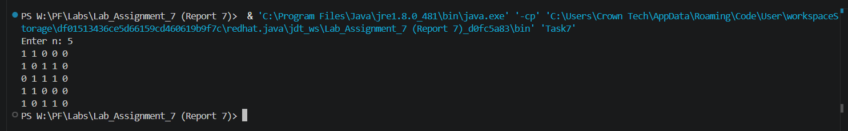

Task 8
Write a Java method to count all vowels in a string. Here is sample run
Enter a string: Welcome to Java
Number of Vowels in the string: 6
import java.util.Scanner;

public class Task8 {

public static int countVowels(String s) {
int count = 0;
for (int i = 0; i < s.length(); i++) {
char c = Character.toLowerCase(s.charAt(i));
if (c == 'a' || c == 'e' || c == 'i' || c == 'o' || c == 'u')
count++;
}
return count;
}

public static void main(String[] args) {
Scanner input = new Scanner(System.in);
System.out.print("Enter a string: ");
String s = input.nextLine();
System.out.println("Number of Vowels in the string: " + countVowels(s));
}
}

Output
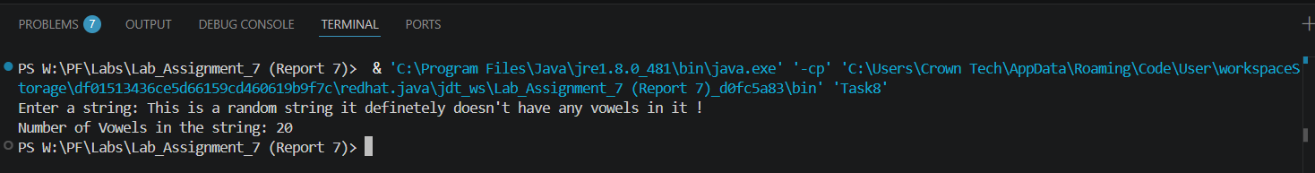

Task 9
Given a positive real number a and a non-negative integer n. Calculate an without using
loops, ** operator or the built in function math.pow(). Instead, use recursion and the
relation an=a⋅an-1. Print the result. Form the method power (a, n)
import java.util.Scanner;

public class Task9 {

public static double power(double a, int n) {
if (n == 0)
return 1;
return a * power(a, n - 1);
}

public static void main(String[] args) {
Scanner input = new Scanner(System.in);
System.out.print("Enter base (a): ");
double a = input.nextDouble();
System.out.print("Enter exponent (n): ");
int n = input.nextInt();
System.out.println(a + "^" + n + " = " + power(a, n));
}
}

Output

